Contents
Campus Resources 3
Academic Counseling (General Counseling) 3
Admissions and Records (A&R) 3
Associated Students Organization (ASO) 3
Back to Success Counseling (Probation) 3
Bookstore 3
Brahma Pantry and Basic Needs Office 4
Business Office 4
CalWORKs 4
Career and Technical Education (CTE) 4
Career Center 5
Center for Academic Success (CAS) (Tutoring Center) 5
Child Development Center 5
Cooperating Agencies Foster Youth Educational Support Program (CAFYES) 5
Cooperative Agencies Resources for Education (CARE) 6
Copy Tech 6
Disabled Students Programs and Services (DSPS) (Special Services) 6
Distance Education (DE) (Pierce Online) 6
Dream Resource Center (DRC) 7
Extended Opportunities, Programs, and Services (EOPS) 7
Financial Aid and Scholarships 7
First Year Experience Center (FYE) 7
Graduation Office 8
Guardian Scholars 8
Honors Transfer Program (HTP) 8
Library 8
Outreach and Recruitment 8
Peer to Peer Mentor Program (P2P) 9
Program for Accelerated College Education (PACE) 9
Roundup! Newspaper 9
Safety Concerns 10
Student Health Center 10
Transfer Center 10
Title IX 10
Umoja Program 10
Veterans Office 11
Veterans Resource Center (VRC) 11
External Resources 12
Assist.org 12
UCLA Center for Community College Partnerships 12
Cranium Café 12
LACCD SIS Portal 12
GradGuru App 12

Campus Resources

Academic Counseling (General Counseling)
Academic Counselors assist students with many of your educational needs, including academic advising, student education plans (SEP), petitions to graduate, and more!
Location: First floor of the Student Services Building (SSB)
Contact: onlinecounseling@piercecollege.edu
http://www.piercecollege.edu/offices/counseling_center/

Admissions and Records (A&R)
Admissions and Records (A&R) help students with a variety of forms and petitions, in addition to the admissions process to enroll as a Pierce College student. A&R assists students with processes such as transcripts, form submissions, and authorizations to release information to other educational institutions, and many more.
Location: First floor of the Student Services Building (SSB)
Contact: https://laccd.craniumcafe.com/group/admissions-and-records-lapc/lobby
http://www.piercecollege.edu/admissions/index.asp

Associated Students Organization (ASO)
LAPC’s Associated Students Organization (ASO) is comprised of student leaders who are the “voice” of its student government. As part of its mission, ASO advocates for LAPC students on the campus, district, state, and national levels. ASO encourages academic and social engagement by facilitating campus events and promoting involvement in ASO clubs.
Location: First floor of the Library and Learning Crossroads (LLC), Room 5100
Contact: (818) 710-2934
http://www.piercecollege.edu/offices/a_s_o/index.asp

Back to Success Counseling (Probation)
Back to Success Counseling provides support to students who fall into academic, progress probation, or dismissal status. The main goal is to educate students on probation and dismissal policies, provide information regarding student services and programs on campus, and develop success strategies through group and individual counseling sessions.
Location: First floor of the Student Services Building (SSB)
http://www.piercecollege.edu/offices/probation/index.asp

Bookstore
The Pierce College Bookstore provides the sale of books and supply requirements connected with the college’s academic programs. Some, but not all, textbook information is available online. On campus, the Bookstore has LAPC apparel, snacks, and supplies for classes.
Location: College Services Building (CSB) 2100
Contact: (818) 719 - 6420
https://www.lapiercecollegestore.com/

Brahma Pantry and Basic Needs Office
The Brahma Pantry and Basic Needs Program provides students with access to food, ongoing motivational support and referrals to agencies that are designed to meet students’ basic needs i.e. physical, psychological/emotional and economic needs. The main goal is to alleviate stressors to help students be successful at the college and beyond!
Location: First floor of the Library and Learning Crossroads (LLC), Room 5100
Contact: corwind@piercecollege.edu
http://www.piercecollege.edu/students/pantry/index-1.asp

Business Office
The LAPC Business Office goal is to assist students to achieve their academic goals by making the fee payment process as simple and efficient as possible.
Location: College Services Building (CSB), Room 2100
Contact: (818) 719 - 6432
http://www.piercecollege.edu/offices/business_office/

CalWORKs
The CalWORKs program includes a variety of services designed to support your educational, career and personal goals is offered, such as advocacy for child care, student education plans (SEP), work-study opportunities, child care in the campus Child Development Center for eligible children, and much more.
Location: Second floor of the Student Services Building (SSB), located in the EOPS Office
Contact: (818) 719 – 6400, conleylc@piercecollege.edu beaverpm@piercecollege.edu
http://www.piercecollege.edu/offices/gaincalworks/

Career and Technical Education (CTE)
The Career and Technical Education Counselor helps students with college and academic advisement, career planning, and assessment, resume writing, internship opportunities, and personal counseling assistance.
Location: Alder Building, Room 1004B
Contact: (818) 710 - 4472
http://www.piercecollege.edu/pierce_career.asp

Career Center
The Career Center educates and serves students in the career education, planning, and development progresses. Career Center services students with the exploration of career options, the cultivation of a comprehensive employment and education plan, and the enhancement of job search techniques and strategies.
Location: Location: First floor of the Student Services Building (SSB)
Contact: (818) 710 – 4126, jobs@piercecollege.edu
http://www.piercecollege.edu/offices/career_center/

Center for Academic Success (CAS) (Tutoring Center)
The Center for Academic Success (CAS) provides one-to-one tutoring, small-group tutoring, and workshops in a variety of subjects offered by the college. English, math, and English as a second language (ESL) tutoring is provided during all hours of operation. Workshops and tutoring in all other subjects have schedules that are available on the website or in the CAS. All services are FREE and available on a walk-in basis. No appointments are necessary, but please call ahead for wait times, schedules, changes.
Location: First floor of Library and Learning Crossroads (LLC), Room 5130
Contact: (818) 719 – 6414, cas-helpdesk@outlook.com
http://www.piercecollege.edu/departments/academic_success/

Child Development Center
The LAPC Child Development Center (CDC) provides free or low-cost child development services to the campus community. The center provides a comprehensive, developmentally appropriate preschool program designed to foster optimum growth of the whole child in a safe and nurturing setting for all children. The CDC also provides an observational work setting for college-level students studying child development, psychology, and nursing.
Location: Child Development Center (3900)
Contact: (818) 719 – 6494, brisbom@piercecollege.edu
http://www.piercecollege.edu/offices/child_development_center/index.asp

Cooperating Agencies Foster Youth Educational Support Program (CAFYES)
Cooperating Agencies Foster Youth Educational Support (CAFYES) promotes the success of current and former foster youth enrolled at LAPC. CAFYES is a program with comprehensive and coordinated sets of services that involve internal and external community partnerships for the purpose of identifying and addressing barriers (including health and well-being) for the academic success of current and former foster youth.
The program is housed within the existing community college program for educationally and economically disadvantaged students, known as Extended Opportunity Programs and Services (EOPS). The program provides service coordination, counseling, book vouchers, tutoring, career guidance, child care and transportation assistance, meal assistance, and grants to assist with the cost of books, housing and other non-tuition costs.
Location: Second floor of the Student Services Building (SSB), located in the EOPS Office
Contact: (818) 719 – 6422, aivazoa@piercecollege.edu
http://www.piercecollege.edu/offices/eops/cafyes.asp

Cooperative Agencies Resources for Education (CARE)
The Cooperative Agencies Resources for Education (CARE) is "a unique educational program geared toward the welfare recipient who desires job-relevant education to break the dependency cycle." The program provides educational planning and vocational assessment, cash grants for education-related expenses, school supplies, meal tickets, child care assistance, textbook assistance, and other services.
Location: Second floor of the Student Services Building (SSB), located in the EOPS Office
Contact: (818) 719 – 6422, aivazoa@piercecollege.edu
http://www.piercecollege.edu/offices/eops/care.asp

Copy Tech
LAPC High-Tech Document Production Center is a location where students can make, print, and copy. Copy Tech also issues picture ID cards to new students upon presentation of proof of enrollment (registration/fee receipt).
Location: College Services Building (CSB) 2100
Contact: (818) 710 – 4422
http://www.piercecollege.edu/offices/copytech/index.asp

Disabled Students Programs and Services (DSPS) (Special Services)
Disabled Students Programs and Services (DSPS) serves students with disabilities, whether physical, learning, or mental health, who believe they may need accommodations in classes or on campus. Students who request this resource are encouraged to contact Special Services a to ensure approved accommodations are implemented in a timely fashion. Authorization, based on verification of disability, is required before any accommodation can be made.
Location: First floor of the Student Services Building (SSB)
Contact: special_services@piercecollege.edu
http://www.piercecollege.edu/offices/special_services/

Distance Education (DE) (Pierce Online)
PierceOnLine is the eLearning platform powered by Canvas, which is the students’ Virtual Classroom. PierceOnLine is used by instructors to post assignments/activities, messages, and other course materials. PierceOnLine is used by many instructors to enhance traditional face-to-face classes, as well as for fully online and blended/hybrid classes.
Location: Online
Contact: onlinehelp@piercecollege.edu
https://online.piercecollege.edu/

Dream Resource Center (DRC)
The Dream Resource Center (DRC) provides support and guidance to undocumented students. The DRC’s goal is to help students achieve your academic and personal aspirations. The DRC is a safe and supportive area to connect with resources and build community.
Location: First floor of the Library and Learning Crossroads (LLC), Room 5100
http://www.piercecollege.edu/students/drc/

Extended Opportunities, Programs, and Services (EOPS)
Extended Opportunities, Programs, and Services (EOPS) is designed to assist qualified low-income and educationally disadvantaged students in completing their educational goals with the assistance of financial and student support services. It is an invitational program open to those who qualify and commit to participate in the program.
Location: Second floor of the Student Services Building (SSB)
Contact: (818) 719 – 6422, aivazoa@piercecollege.edu
http://www.piercecollege.edu/offices/EOPS/

Financial Aid and Scholarships
Financial Aid provides students with resources to make educational expense decisions, such as fees, non-resident tuition, books, supplies, transportation, and housing.
Location: Second floor of the Student Services Building (SSB)
Contact: https://laccd.craniumcafe.com/group/financial-aid--lapc/lobby
http://www.piercecollege.edu/offices/financial_aid/

First Year Experience Center (FYE)
The First Year Experience (FYE) Counseling Center serves in the educational planning, matriculation, and adjustment needs of all new and first year LAPC students. Counselors provide guidance in clarifying educational goals, picking a major, and determining what classes to take.
Location: First floor of the Library and Learning Crossroads (LLC), Room 5110
Contact: onlinecounseling@piercecollege.edu
http://www.piercecollege.edu/students/nsp/index.asp

Graduation Office
The Graduation Office assist students with questions regarding applying to graduate, completing an Associate Degree of Transfer (ADT), obtaining a copy of a diploma or certificate, or participating in the commencement ceremony.
Location: First floor of the Student Services Building (SSB)
Contact: piercegraduation@piercecollege.edu
http://www.piercecollege.edu/admissions/grad.asp

Guardian Scholars
The Pierce College Guardian Scholars Program is designed as a one-stop center to support current and former foster youths achieve their educational goals to either complete a certificate, associates degree, or transfer to a university. Program counselors can assist with college admissions application, developing an educational plan, and financial aid applications.
Location: Second floor of the Student Services Building (SSB), located in the Financial Aid Office
http://www.piercecollege.edu/offices/foster_youth/index.asp

Honors Transfer Program (HTP)
Participating in the Pierce College Honors Transfer Program (HTP) allows students to take challenging honors coursework that help to build the academic skills necessary for successful transfer to competitive four-year universities. Completion of the HTP requirements gives students priority consideration for admission to the UCLA College of Letters and Sciences and many other competitive four-year institutions.
Location: Alder Building 1000
Contact: (818) 712 – 2603, honors@piercecollege.edu
http://www.piercecollege.edu/offices/honors/

Library
The Pierce College Library serves all currently enrolled students, faculty, and staff. Come to the library for a quiet place to study, to get help with research, to use a computer or printer, or to just relax. A reference librarian is always available to assist you with your research needs.
Location: Second floor of the Library and Learning Crossroads (5100)
Contact: library@piercecollege.edu
https://library.piercecollege.edu/home

Outreach and Recruitment
The Outreach and Recruitment Office (OAR) serves the surrounding West San Fernando Valley community by providing access to students who wish to pursue their higher education goals. OAR provides information regarding vocational, certificate, degree and/or transfer programs to Pierce College’s local feeder high schools. OAR promotes and develops programs to increase access to education within all systems of higher education, including the promotion of community college as an educational option leading to a baccalaureate degree. OAR assists students with the Matriculation and Financial Aid processes and offers accelerated program options including concurrent enrollment courses for K-12 students.
Location: First floor of the Student Services Building (SSB)
Contact: outreach@piercecollege.edu
http://www.piercecollege.edu/students/high_school_outreach/

Peer to Peer Mentor Program (P2P)
The Peer to Peer Mentor Program’s mission is to support the transition of incoming students into LAPC by providing support, information, and guidance to increase student success academically, socially, and emotionally.
Location: First floor of the Library and Learning Crossroads (LLC), Room 5100
Contact: (818) 710 – 2957, LAPC-P2P@laccd.edu
http://www.piercecollege.edu/students/peertopeer/

Program for Accelerated College Education (PACE)
The Program for Accelerated College Education (PACE) is special LAPC program designed to provide students with the ability to graduate in two years. PACE coursework is compressed to fit into 8-week quarters, instead of 16-week semesters. PACE classes follow the CSU & IGETC GE certified plans that can be applied to ANY Associate Degree for Transfer program.
Location: Alder Building 1000, Room 1000B
Contact: (818) 719 – 6485
http://www.piercecollege.edu/departments/pace/

Roundup! Newspaper
The Roundup is a student-run news publication serving the campus community both online and in-print. The First Amendment publication is comprised of various sections from the Media Arts Department including: Journalism 202, Journalism 219 and Photography 20/21.
Location: Pierce Village
Contact: (818) 710 – 4115, newsroom.roundupnews@gmail.com
https://theroundupnews.com/category/news/

Safety Concerns
In case of emergency: When on campus, call (818) 710-4311 for immediate response from the Campus Sheriff. Do not call 911, as this will result in a substantial delay. Please program the Emergency Sheriff’s number into your cell phone contacts.
Location: Sheriff’s Office
Contact: Emergency Number: (818) 710 – 4311, Non-emergency number: (818) 719-6450
http://www.piercecollege.edu/campus_safety.asp

Student Health Center
The Student Health Center is committed to delivering expert medical care to students. Each student is given professional and cost-effective medical attention. All registered students, regardless of insurance, are eligible for the same no charge or low-cost care. Personal counseling is also available to all currently enrolled students. The Student Health Center staff is committed to providing care to support students’ academic and personal well-being.
Location: Second floor of the Student Services Building (SSB)
Contact: (818) 710 – 4270
http://www.piercecollege.edu/offices/health_center/

Transfer Center
The Transfer Center’s mission is to help students successfully transfer to a four-year institution. The Transfer Center offers aid to students in the transfer process to ensure a smooth and positive transition. Whether it is a transfer workshop or a quick question regarding the transfer process – this is the place to go!
Location: First floor of the Student Services Building (SSB)
Contact: (818) 710 – 2907, lapc-transfer@piercecollege.edu
http://www.piercecollege.edu/offices/transfer_center/

Title IX
Title IX is a federal law that prohibits gender-based discrimination which includes sexual harassment, sexual misconduct, dating/domestic violence, and stalking. If you have a concern related to Title IX or needs resources, the colleges Title IX coordinator can assist. Contact the Title IX office located on the 3rd floor of the Students Services Building (SSB) 48314 at (818) 710-4228 to speak with campus Title IX Coordinator.

UMOJA Program
UMOJA is a Kiswahili word meaning unity. It is an academic learning community and a resource dedicated to enhancing the cultural and educational experiences of African-American students and others. UMOJA is open to any individual that is interested in learning and taking part in the African-American experience. Students must attend an orientation and agree to UMOJA Program requirements to be considered an UMOJA student.
Location: First floor of the Library and Learning Crossroads (LLC), Room 5114
Contact: (818) 710 – 3302, umojaprogram@piercecollege.edu
http://piercecollege.edu/offices/umoja/

Veteran’s Office
The mission of the Veterans Office is to provide a supportive environment for veterans and to assist them with the services needed to receive VA benefits and to successfully complete educational goals. The Veteran's Office is designed as a liaison between you as a veteran and the Veterans Administration. Our veteran's staff will forward all documents required by the Veterans Administration directly to the Muskogee Regional Office.
Location: Second floor of the Student Services Building (SSB), located in the Financial Aid Office
Contact: (818) 710 – 3316
pierce-veteran@piercecollege.edu http://www.piercecollege.edu/offices/Veterans/va_vs.asp
http://www.piercecollege.edu/offices/veterans/

Veterans Resource Center (VRC)
The Veterans Resource Center (VRC) provides services and guidance to help student veterans and their dependents. The VRC lead helps facilitate a smooth transition from military service to the classroom and helps student veterans best utilize their educational benefits.
Location: First floor of the Library and Learning Crossroads (LLC), Room 5155
Contact: (818) 710 – 3316, pierce-veteran@piercecollege.edu
http://www.piercecollege.edu/offices/Veterans/vrc.asp

External Resources

Assist.org
ASSIST is an online student-transfer information system that shows how course credits earned at one public California college or university can be applied when transferred to another. ASSIST is the official repository of articulation for California’s public colleges and universities and provides the most accurate and up-to-date information about student transfer in California.
www.assist.org

UCLA Center for Community College Partnerships
The transfer process begins long before you enter the four-year institution and CCCP is here to motivate, inform, and prepare students for their transfer journey.
www.cccp.ucla.edu

Cranium Café
Cranium Café is the online system for providing counseling and other student services in a remote format. Students can chat with a student services representative via text and video chat. Students can set appointments or chat directly with individuals during “drop-in” hours and can send direct messages to staff members using the email system.
https://laccd.craniumcafe.com/directory/by-department

IGETC Information
The IGETC provides undergraduate students with a general overview of the major subject areas that are required in order to transfer to colleges in the UC system. It also provides the number of units that transfer candidates will need to complete in each major subject area. However, please make sure to review all transfer plans with a counselor to ensure that courses align with transfer requirements.
https://admission.universityofcalifornia.edu/counselors/transfer/advising/igetc/

LACCD SIS Portal
The LACCD SIS Portal is the student information system that allows students to access valuable information such as enrollment date, personal information, enrollment dates, and other information. It also provides students with quick access to a variety of services and resources such as Canvas, course enrollment, online student services, and much more.
https://sso.laccd.edu/adfs/ls/idpinitiatedsignon.aspx?loginToRp=csprd.laccd.edu

GradGuru App
GradGuru is an award-winning mobile platform that increases community college student persistence and completion by delivering free nudge notifications, and so much more, right to their smartphones.
https://www.gradguru.org/
Campus Map
To access a higher resolution map, click here to visit the Pierce College website campus map webpage: http://www.piercecollege.edu/schedules/mapcampus.pdf
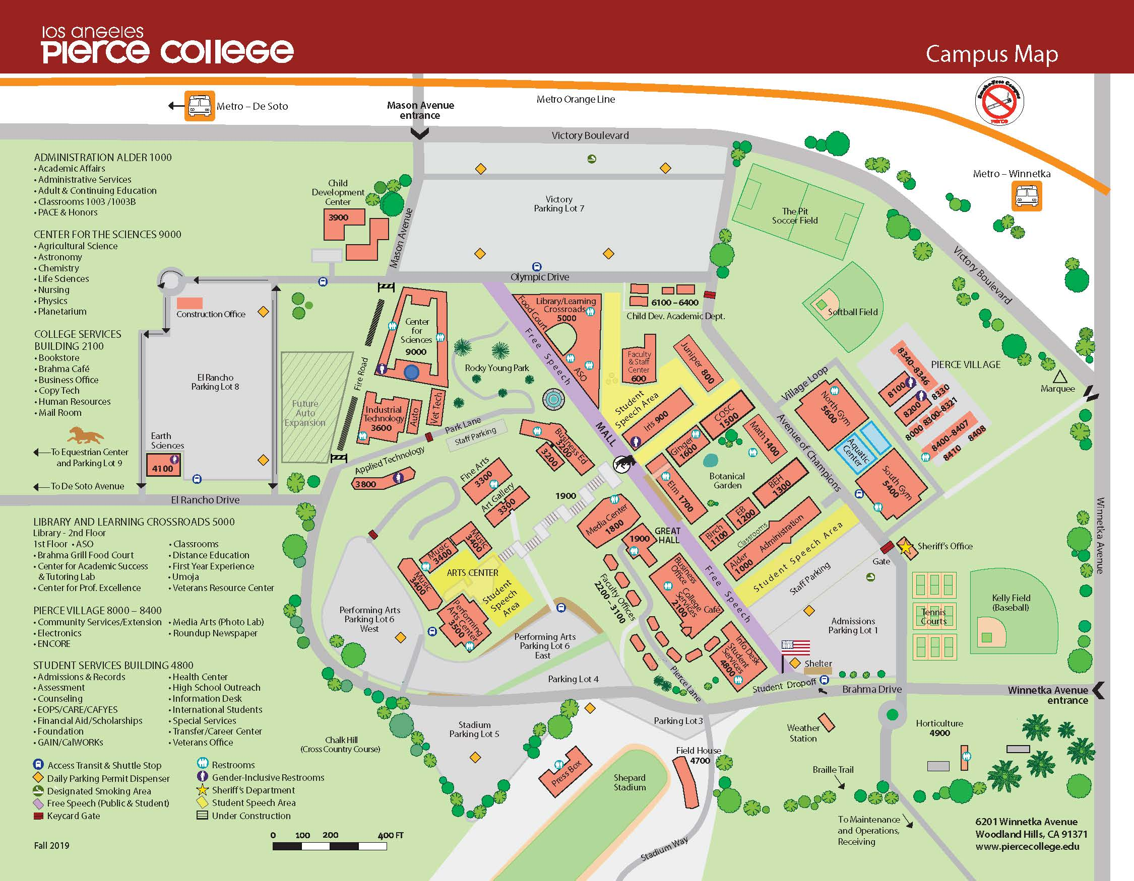

Campus Map – Village Focus
To access a higher resolution map of the Pierce Village, click here to visit the Pierce College Pierce Village webpage: http://www.piercecollege.edu/schedules/mapvillage.pdf
